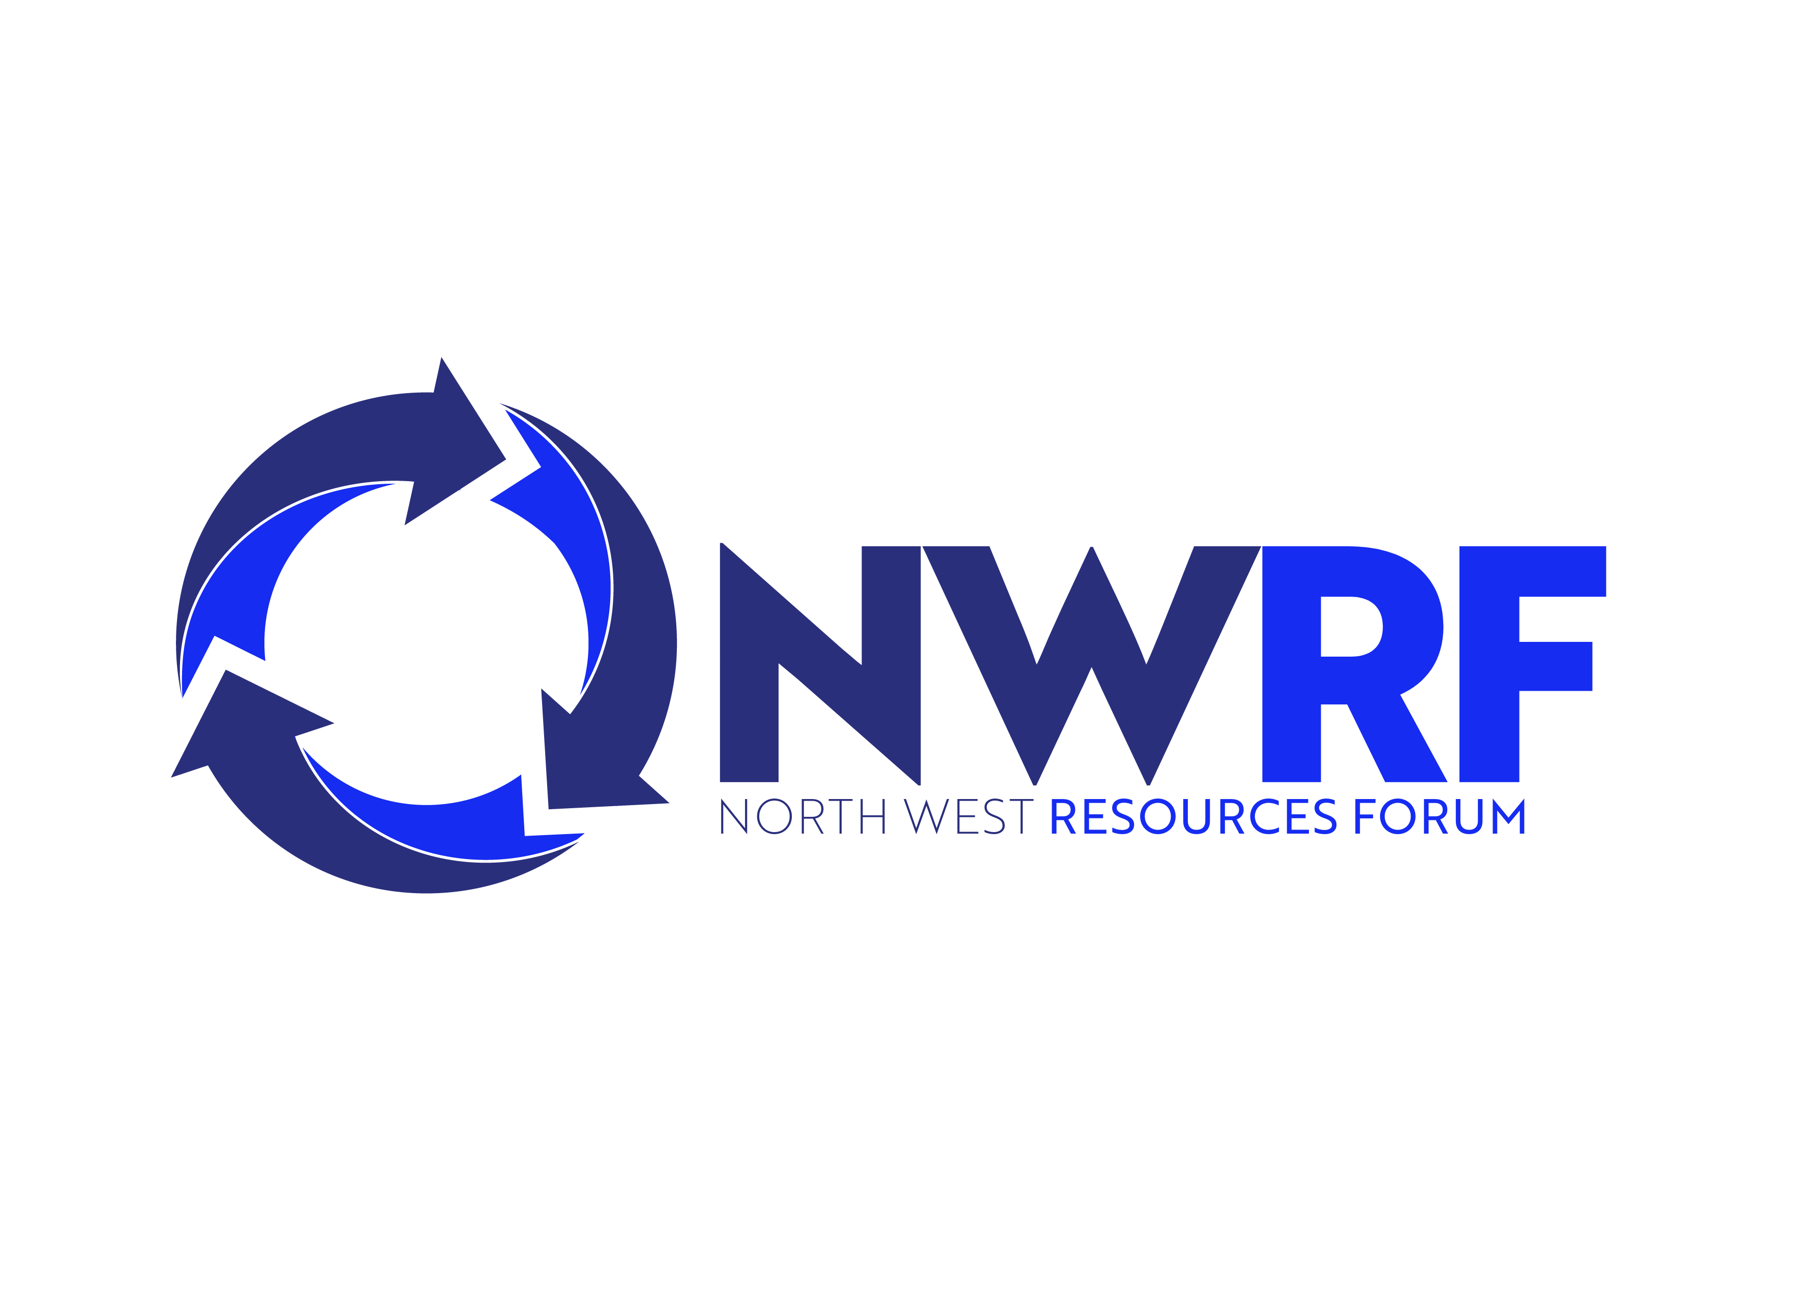

Dear North West Resources Forum,

I would like to become a Friend of the NWRF. My details are:

Name:

Organisation:

Address

Postcode:

Tel:

Email:

I would like to be a:

Bronze Friend
£250 per year

Silver Friend
£500 per year

Gold Friend
£1000 per year

Please send this completed form to:

Jo Holmes
The Steadings,
Glebe Farm,
Woodside,
Tyne & Wear,
NE40 4SY

For further details email jo@genee.org.uk or telephone 07815 754931

